# OBJECT DETECTION USING OPENCV (Computer Vision) with Transfer Learning

*Hey Uptrain Community!*

*My name is Abhay Chourasiya.*

The uploaded file is a Model of Object Detection able to detect 80 classes with weights of famous COCO dataset trained using MobileNet.

The change made in Repository is addition of a new Computer Vision use-Case Model of Object Detection.

***The Explanation***

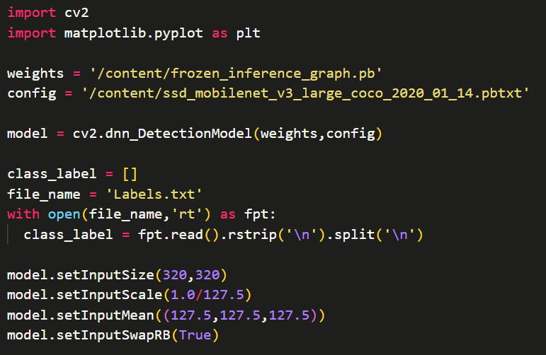

This Snippet is a Heart of the Model.

‘weights’ variable consist the location of the Frozen_ineferance Model also present in Weights Folder.

Configuration is containing a information about the model and the size colour requirement of Model.

file_name consist a file of 80 Label names listed present in Folder.

Then I used to set the requirements according to configuration of the model to smoothly run the program with normalization of whole pixel data of Images.

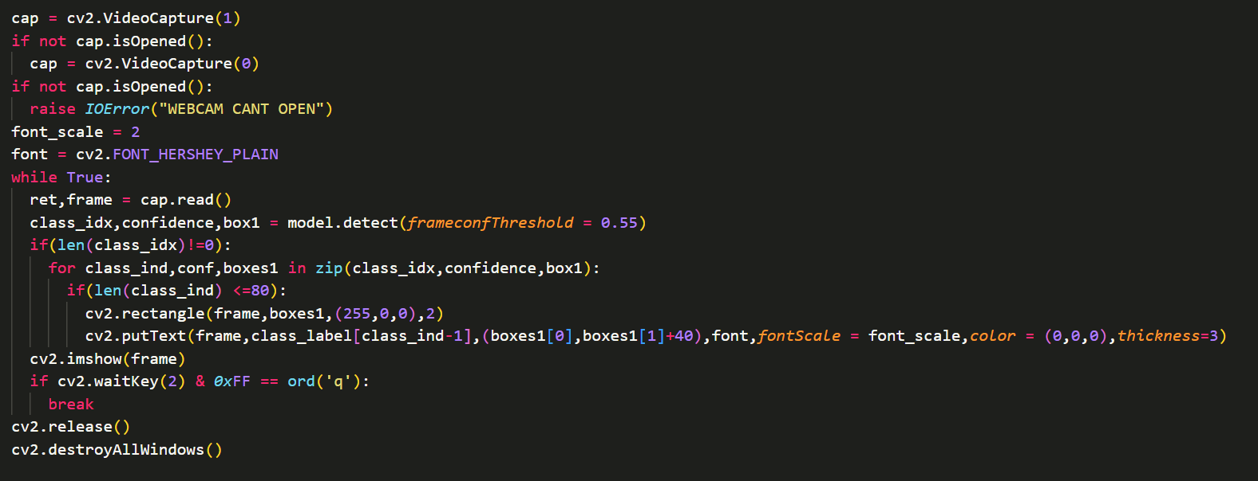

This code is used to open a webcam for Live Object Detection.

We use OpenCV to Open a webcam and then check for a successful opening of Webcam.

After that I set a Rectangle and a Classified Class name using cv2 and the loop is run for infinite time till closed manually.

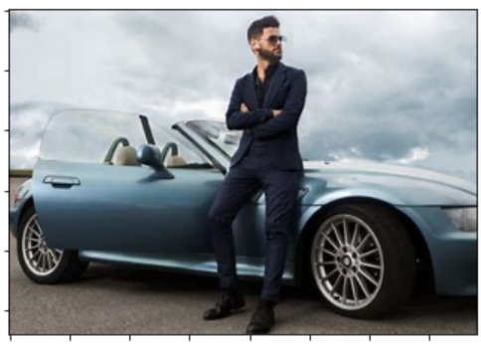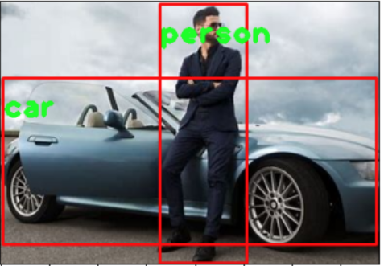

This is a Test Image used to test the model accuracy with label as text and rectangle made on image and also in runtime.

Thanks to ReadMe😉!